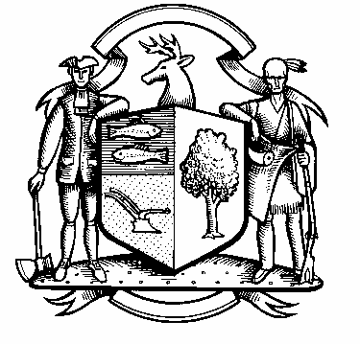

Board of Police Commissioners
Tuesday, February 7, 2023 Meeting Minutes
7:00 PM Town Hall Meeting
Commission Room

Board of Police Commissioners Panelists: Police Board Chairman Beth Gralnick, Police Board Vice Chairman Jess DiPasquale, Police Board Commissioners Dawn Egan, David Muller, Peter Ottomano, Woody Bliss and John Dembishack

Others Present: Chief Henion and Captain Brodacki
Police Board Chairman Gralnick called the meeting to order at 7:00 PM
Police Board Chairman Gralnick asked for a motion to approve the meeting minutes dated January 3, 2023, Police Board Commissioner Bliss seconded, and unanimously approved. Police Board Vice Chairman DiPasquale, Police Board Commissioners Muller and Egan abstained.

Chief Henion reported to the meeting that the Police Department’s overtime is down. We have two officers out. The Weston Police Department had a walk through with the Architect and his staff.

The 2023 Budget was transmitted to the Board of Selectmen.
Chief Henion reported to the Commissioners that the $5,000.00 speed grant that he applied for from ARPA funds through the State of Connecticut has been approved.

Daigle Law – Accreditation Update – The Chief and Captain continue working with the Daigle Law Group on getting policies updated.

Additional Business for Commission Consideration

Detective Exam – The Detective Exam has been announced. On March 24, 2023 will be the oral exam and on April 3, 2023 the written exam.

Police Board Chairman Gralnick made a motion to go into Executive Session at 7:35 PM. Police Board Commissioner Bliss seconded, and unanimously approved.

The Commissioners came out of Executive Session at 8:30 PM and adjourned.

Respectfully submitted
Mary Gunshor
Board of Police Commissioners Recording Secretary
Approved 3/7/2023

