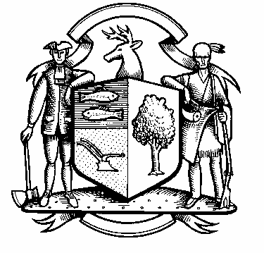

Board of Police Commissioners
Tuesday, September 6, 2022 Meeting Minutes
7:00 PM Town Hall Meeting
Commission Room
Board of Police Commissioners Panelists: Police Board Chairman Beth Gralnick, Police Board Commissioners Peter Ottomano, Woody Bliss, Dawn Egan and John Dembishack

Absent: Vice Chairman Jess DiPasquale

Others Present: Chief Henion and Captain Brodacki
Police Board Chairman Gralnick called the meeting to order at 7:00 PM
Police Board Chairman Gralnick asked for a motion to approve the meeting minutes dated August 2, 2022, Police Board Commissioner Ottomano seconded and unanimously approved.
Chief Henion reported to the meeting that the police departments overtime for August was less than it was the previous year in August by $25,700.00. The Chief and Captain will be putting out an advertisement for the position of Detective.

Grant Updates / Donations – None

Additional Business for Commission Consideration – Police Board Commissioner Muller would like the Police Department to create a master list of road improvements.

Chief Henion reported to the Commissioners that the State is coming on May 23, 2023 to inspect us for accreditation standards. The Chief and Captain are working with The Daigle Law Group on getting 153 policies ready.

Citizen of the Year will be discussed at our next meeting.

Police Board Chairman Gralnick made a motion to go into Executive Session at 7:42 PM, Police Board Commissioner Egan seconded, all in favor.

The Commissioners came out of Executive Session at 8:20 PM and adjourned.

Respectfully submitted
Mary Gunshor
Board of Police Commissioners Recording Secretary
Approved 10/11/2022

