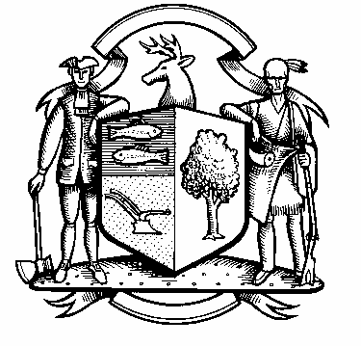

Incorporated 1787

Board of Police Commissioners
Tuesday, June 7, 2022 Meeting Minutes
7:00 PM Commission Room
UNAPPROVED
Board of Police Commissioners Panelists: Police Board Chairman Beth Gralnick, Police Board Vice Chairman Jess DiPasquale, Police Board Commissioners John Dembishack, Peter Ottomano, Woody Bliss and David Muller

Police Board Commissioner Dawn Egan Absent
Others Present: Chief Henion, Captain Brodacki and Town Residents
Police Board Chairman Gralnick called the meeting to order at 7:00 PM
Police Board Chairman Gralnick asked for a motion to approve the meeting minutes dated May 3, 2022, Police Board Commissioner Ottomano moved, the motion was seconded by Vice Chairman DiPasquale and unanimously approved. Police Board Commissioner Muller abstained.
Chief Henion reported to the meeting that the officers attended training in May. Overtime for May was $4,474,00 less than the same time as last year. CIRMA reimbursement for May was $5,269.92. Weston had 8 motor vehicle car thefts this year.
Grant Updates / Donations – Anne and Travis Engen a donation for $25,000.00 for two trailer mounted speed control equipment.

Police Board Commissioner Muller accepts the $25,000.00 donation for two trailer mounted speed control equipment, Police Board Commissioner Dembishack seconded and unanimously approved. Board of Selectman has to approved.

Additional Business for Commission Consideration – None at this time.
Eric Hasenauer – A request for a stop sign at the intersection of Godfrey Road W and Mountain View Road – Discussion regarding average speed and volume on roads.
John Conte Town Engineer and Director of Public Works recommendations are:
- Do not place a stop sign in west bound lane on Godfrey Road West.
- Trim branches back from sight line facing west from the intersection.
- Remove boulders from south east corner of intersection.
- Install an intersection warning sign in west bound on Godfrey Road West before reaching Mountain View Drive.
- Move stop sign and stop bar on Mountain View Drive closer to intersection with Godfrey Road West.

Chairman Gralnick made a motion to approve John Conte’s recommendations, Police Board Commissioner Muller seconded, all in favor.
Right side road sign at intersection of Cartbridge Road and Nordholm Drive – Discussion regarding intersection. John Contes recommendations is to put a slow sign road east bound on Cartbridge Road with an intersection sign.

Police Board Commissioner Muller made a motion to approve John Contes recommendations, The motion was seconded by Vice Chairman DiPasquale, all in favor.

Police Board Chairman Gralnick made a motion to go into Executive Session at 8:15 PM, Police Board Commissioner Muller moved and Police Board Commissioner Ottomano seconded, all in favor.
The Commissioners came out of Executive Session at 9:40 PM and adjourned.

Respectfully submitted
Mary Gunshor
Board of Police Commissioners Recording Secretary

