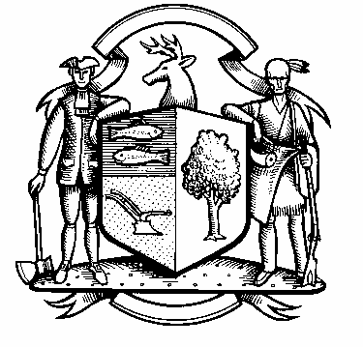

Incorporated 1787

Board of Police Commissioners
Tuesday, May 3, 2022 Meeting Minutes
7:00 PM ZOOM Meeting
UNAPPROVED
Board of Police Commissioners Panelists: Police Board Chairman Beth Gralnick, Police Board Vice Chairman Jess DiPasquale, Police Board Commissioners John Dembishack, Peter Ottomano, Woody Bliss, Dawn Egan

Police Board Commissioner David Muller Absent
Others Present via Zoom: Chief Henion and Captain Brodacki
Police Board Chairman Gralnick called the Zoom meeting to order at 7:00 PM
This meeting is being recorded.

Police Board Chairman Gralnick asked for a motion to approve the meeting minutes dated April 5, 2022, Police Board Commissioner Dembishack moved, the motion was seconded by Police Board Commissioner Peter Ottomano and unanimously approved.
Chief Henion reported to the meeting that he attended the ATBM and there was no quorum. Overtime for April was $20,086 including mile of safety. CIRMA reimbursement for April was $5,269.92.

Grant Updates / Donations – Dana and Steven Spencer trust foundation for $500.00.
Chairman Gralnick asked for a motion to approve the $500.00 donation. Police Board Commissioner Egan accepts the $500.00 donation with appreciation and gratitude, Police Board Vice Chairman DiPasquale seconded and unanimously approved.

Additional Business for Commission Consideration – SRO officers Joe Mogollon and Jason Kim conducted a DUI education program for the high school students. The student is the driver of a golf cart and the SRO officer is in the golf cart with them. The student wears goggles over their eyes which simulate blurred vision while driving the cart on the turf field around cones. The student realizes they cannot drive around the cones they end up knocking them down. It shows them how serious it is to drink and drive.
For the month of April Weston had 2 cars stolen and were quickly recovered. For the year 2022 Weston had 4 stolen vehicles so far.
One of our Commissioners sponsored SRO Jason Kim to shave his head for St. Baldricks fundraiser.
Chief Henion spoke on Lisa Wexler’s radio show regarding cars being stolen. The Chief recommends lock your cars and never leave your keys in the car.
Police Board Commissioner John Dembishack wanted to publicly thank Chief Henion for attending so many meetings in town as a department head.
Eric Hasenauer – A request for a stop sign at the intersection of Godfrey Road W and Mountain View Road - Police Board Chairman Gralnick stated we as a local traffic authority we can approve and disapprove a stop sign. The Police Commission will ask John Conte, the Town Engineer to do a survey of the road and ask for his recommendations.
The police department will put a speed monitoring device (pizza box) at the intersection of Godfrey Road W and Mountain View Road to see how many cars drive on the road, how many accidents have happened on the road. At our next meeting in June, we will discuss further.
Citizen of the Year – Vice Chairman DiPasquale will continue to do Citizen of the Year Award for 2022. The Police Department will probably hold it sometime in September 2022.
Police Board Chairman Gralnick made a motion to go into Executive Session at 7:50 PM, Police Board Commissioner DiPasquale moved and Police Board Commissioner Bliss seconded, all in favor.
For more details, please refer to the video recording found here:
https://vimeo.com/manage/videos/706169224

The Commissioners came out of Executive Session at 9:00 PM and adjourned.

Respectfully submitted
Mary Gunshor
Board of Police Commissioners Recording Secretary

