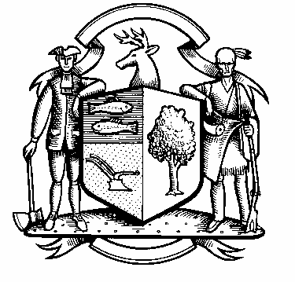

Incorporated 1787

Board of Police Commissioners
Tuesday, March 1, 2022 Meeting Minutes
7:00 PM Webinar Meeting
UNAPPROVED

Board of Police Commissioners Panelists: Police Board Chairman Beth Gralnick, Police Board Vice Chairman Jess DiPasquale, Police Board Commissioners John Dembishack, Peter Ottomano, Woody Bliss, Dawn Egan and David Muller
Others Present via Webinar: Chief Henion and Captain Brodacki
Police Board Chairman Gralnick called the Webinar meeting to order at 7:03 PM
This meeting is being recorded.

Police Board Chairman Gralnick asked for a motion to approve the Meeting Minutes dated February 1, 2022, Police Board Commissioner Bliss moved, the motion was seconded by Police Board Commissioner David Muller and unanimously approved.
Chief Henion reported to the meeting that the police departments CIRMA reimbursement for February was $14,978.78. Overtime was $17,659.00 including Mile of Safety. The Chief presented his budget to the Board of Selectman. March 8, 2022 it will be presented to the Board of Finance.

In addition, Chief Henion reported that the department has received a $10,000.00 donation from the Lester CAIT Trust.
Chairman Gralnick asked for a motion to approve the $10,000.00 donation, Police Board Commissioner Muller approved the generous donation from the Lester CAIT Trust, Police Board Commissioner Ottomano seconded and unanimously approved.

The Weston Police are following safety and health precautions to mitigate COVID-19 spreading. The officers are still wearing masks on medical calls.

Update Pursuit Policy - Policy Review – Discussion on Pursuit Policy. Police Board Commissioner Dembishack made a motion to adopt in its entirety Police Motor Vehicle Pursuit Policy dated November 18, 2021 to replace the current Weston Police Department policy, Police Board Commissioner Egan seconded, unanimously approved.
Ring Camera Program – Update – Discussion regarding evidence.com, data cost and storage.

Additional Business for Commission Consideration- Chief Henion – Drug take back program took forty-four pounds of prescription drugs to Wheelabrator in February.
Valley Forge Road between Route 53 and Godfrey Road East is eroding. The road will be closed and they will set up a detour.
Old Mill Road down by the dirt section the road is collapsing. The road will be fixed and they will set up a detour.
Fanton Hill Road by Tall Pines road the stop sign will be moved about 30 Feet.

Use of Body Worn and Dashboard Cameras Policy – Discussion
Discussion regarding extra duty car fees and surrounding towns.
Police Board Chairman Gralnick made a motion to raise the extra duty car fees from $18.00 an hour to $25.00 an hour, Police Board Commissioner DiPasquale seconded, unanimously approved.
Police Board Chairman Gralnick made a motion to go into Executive Session at 8:31 PM, Police Board Commissioner Egan moved and Police Board Commissioner Muller seconded, all in favor.
For more details, please refer to the video recording found here:
https://vimeo.com/683825871

The Commissioners came out of Executive Session at 9:30 PM and adjourned.

Respectfully submitted
Mary Gunshor
Board of Police Commissioners Recording Secretary

