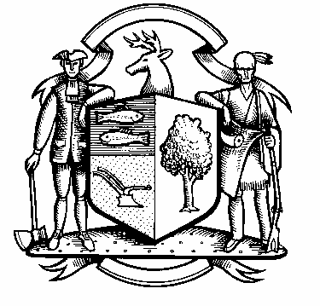

Incorporated 1787

Board of Police Commissioners
Tuesday, December 7, 2021 Agenda
Police Board Meeting
7:00 PM Town Hall Meeting Room

- Consideration / Approval November 3, 2021 Meeting Minutes

- Chief’s Report
- Current Monthly Reports / OT / Budget (Changes) Updates
- Grant Updates / Donations / Vote
- COVID – 19
- Police Engagement Program (PEP) – Update
- Policy Review
- Additional Business for Commission Consideration

- Discussion/Decision / Fingerprinting Fee for Towns New Personnel

- 2022 Meeting Calendar

- Executive Session / Personnel Updates / Investigation Updates / Security Issues / Juvenile Review
Board Updates / Criminal Activity Updates / Complaints / Traffic Concerns / Union Contract Pending Litigation

- Motion to Adjourn

