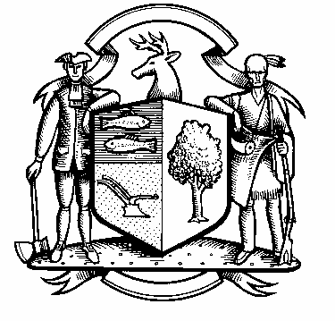

Incorporated 1787

Board of Police Commissioners
Wednesday, November 3, 2021 Agenda
Police Board Meeting
7:00 PM Meeting
Please click the link below to join the webinar:
https://us02web.zoom.us/j/86470508185?pwd=N1pZR25QODBOUC8wZTJORk1jOGhTQT09
Passcode: 073850
Webinar ID: 864 7050 8185
Join by phone: 646 558 8656

- Consideration / Approval October 5, 202 Meeting Minutes and October 26, 2021 Special Meeting Minutes

- Chief’s Report
- Current Monthly Reports / OT / Budget (Changes) Updates
- Grant Updates / Donations / Vote
- COVID – 19
- Police Engagement Program (PEP) - Update
- Additional Business for Commission Consideration

3. Executive Session / Personnel Updates / Investigation Updates / Security Issues / Juvenile Review
Board Updates / Criminal Activity Updates / Complaints / Traffic Concerns / Union Contract Pending Litigation

4. Motion to Adjourn

