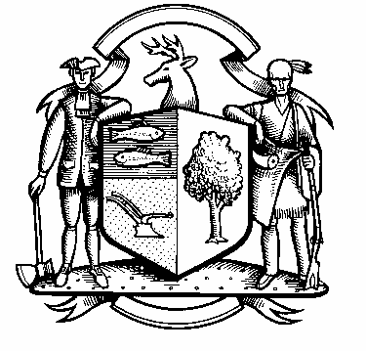

Incorporated 1787

Board of Police Commissioners
Tuesday, October 26, 2021 Special Meeting Minutes
7:00 PM Commission Room
UNAPPROVED
Board of Police Commissioners Panelists: Police Board Chairman Beth Gralnick, Police Board Vice Chairman Jess DiPasquale, Police Board Commissioners Susan Moch, Peter Ottomano, Woody Bliss, and Dawn Egan
Others Present: Chief Edwin Henion
Absent: Police Board Commissioner David Muller

The meeting was called to order at 7:00 PM

The commission went into Executive Session to interview Police Officer candidates.
The commission came out of Executive Session to at 9:15 PM.

Police Board Chairman Gralnick made a motion to extend to Steven Vichiola a Conditional Offer of Employment as a Regular Police Officer with the Weston Police Department. Police Board Commissioner Moch seconded. The vote was all in favor.

The meeting adjourned at 9:50 PM.

Respectfully submitted
Chairman Beth Gralnick

