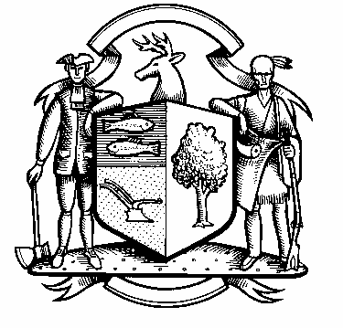

Incorporated 1787

Board of Police Commissioners
Tuesday, October 5, 2021 Agenda
Police Board Meeting
7:00 PM Meeting
Please click the link below to join the Webinar

Board of Police Commissioners
Oct 5, 2021 07:00 PM Eastern Time (US and Canada)
Please click the link below to join the webinar:

https://us02web.zoom.us/j/89062673660?pwd=aDZwYWV6cmdOWGd2Rmh2Q1gzeHZQdz09
Webinar ID: 890 6267 3660
Passcode: 517463
Join by phone: 646 558 8656

- Consideration / Approval September 14, 2021 Special Meeting Minutes

- Chief’s Report
- Current Monthly Reports / OT / Budget (Changes) Updates
- Grant Updates / Donations / Vote
- COVID – 19
- New Police Officer Hiring Process
- Additional Business for Commission Consideration

3. Executive Session / Personnel Updates / Investigation Updates / Security Issues / Juvenile Review
Board Updates / Criminal Activity Updates / Complaints / Traffic Concerns / Union Contract Pending Litigation

4. Motion to Adjourn

