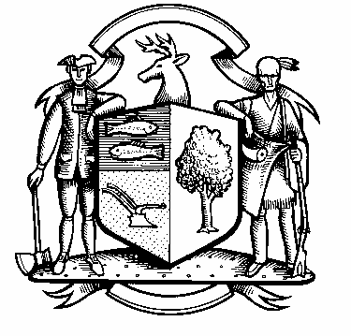

Incorporated 1787

Board of Police Commissioners
Tuesday, August 3, 2021 Meeting Minutes
7:00 PM Zoom Webinar Meeting
Board of Police Commissioners Panelists: Police Board Chairman Beth Gralnick, Police Board Vice Chairman Jess DiPasquale, Police Board Commissioners Susan Moch, Dawn Egan, Peter Ottomano, Woody Bliss and David Muller
Others Present via Webinar: Chief Henion and Captain Brodacki
Attendees: Weston Residents via Webinar
Police Board Chairman Gralnick called the Zoom Webinar meeting to order at 7:00 PM
This meeting is being recorded.

Police Board Chairman Gralnick made a motion to approve the meeting minutes dated June 1, 2021, Police Board Commissioner Ottomano moved, the motion was seconded by Police Board Commissioner Bliss and unanimously approved.
Chief Henion reported to the meeting that the PD received $13,096.84 for CIRMA payments for the month of July due to officers out with injuries.

In addition, Chief Henion reported that the department has not received any donations or grants in the month of July.

Chief Henion reported as to the status of the facilities renovations at the Police Station by stating that we have a CO. Minor issues with some of the computer equipment that needs to be completed.

The Weston Police are following safety and health precautions to mitigate COVID-19 spreading.

Additional Business for Commission Consideration – Pent Road – Police Board Commissioner Ottomano spoke with Chris Reeb. Chris stated he and his neighbors on Pent Road would like permanent no parking signs on Pent Road. The Chief stated he will talk to the Town Engineer/DPW Director John Conte to see where they can place additional signs. There is also additional parking at Morehouse Park. Chairman Gralnick will put it on the September Agenda to discuss John Contes recommendations.
Body/In Car Camera – Update -Chief Henion stated the board of finance approved the supplemental body/in car camera last month. The towns legal counsel looked over the contract before the Chief signed it and it was approved for five years. For more details, please refer to the video recording for more details.
Civilian Review Board Ordinance – Chairman Gralnick stated there will be a public hearing on this sometime in September 2021. The date will be set by the Board of Selectman. Please refer to the video recording for more details.

Discussion – Community Engagement Day for October – Police Board Commissioner Egan suggested the police department have a bicycle rodeo program with the Kiwanis Club. Chief Henion stated we are doing a Police Engagement Program in September and coffee with a police officer. The Chief said he is waiting for school to start and they will pick dates. The Commissioners decided to table the bicycle rodeo until the spring.
Sub-Committee Reports – None at this time.
Police Board Chairman Gralnick made a motion to go into Executive Session at 8:05 PM, Police Board Commissioner Muller moved and Police Board Commissioner DiPasquale seconded, all in favor.
For more details, please refer to the video recording found here:
https://vimeo.com/583496360

The Commissioners came out of Executive Session at 9:15 PM and adjourned.

Respectfully submitted
Mary Gunshor
Board of Police Commissioners Recording Secretary
Approved 9/14/21

