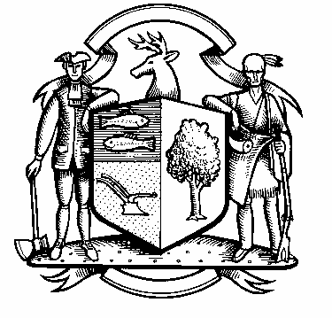

Incorporated 1787

Board of Police Commissioners
Tuesday, August 3, 2021 Agenda
Police Board Meeting
7:00 PM Meeting
Please click the link below to join the Webinar

https://us02web.zoom.us/j/88305160361?pwd=elJWcmRWOFNqdWpqY2Rhd0diYndTUT09
Webinar ID: 883 0516 0361
Passcode: 890936
Dial by phone: 646 558 8656

- Consideration / Approval July 6, 2021 Meeting Minutes

- Chief’s Report
- Current Monthly Reports / OT / Budget (Changes) Updates
- Grant Updates / Donations / Vote
- Facilities Update
- COVID – 19
- Additional Business for Commission Consideration

- Body/In Car Camera - Update

- Discussion – Civilian Review Board Ordinance

- Discussion – Community Engagement Day for October

- Sub-Committee Reports

9. Executive Session / Personnel Updates / Investigation Updates / Security Issues / Juvenile Review
Board Updates / Criminal Activity Updates / Complaints / Traffic Concerns / Union Contract

- Motion to Adjourn

