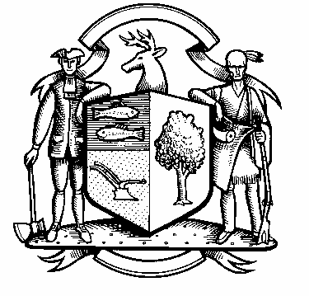

Incorporated 1787

Board of Police Commissioners
Tuesday, June 1, 2021 Meeting Minutes
7:00 PM Zoom Webinar Meeting
Board of Police Commissioners Panelists: Police Board Chairman Beth Gralnick, Police Board Vice Chairman Jess DiPasquale, Police Board Commissioners Susan Moch, Dawn Egan, Peter Ottomano and David Muller
Police Board Commissioner Woody Bliss - Absent

Others Present via Webinar: Chief Henion and Captain Brodacki
Attendees: Weston Residents via Webinar
Police Board Chairman Gralnick called the Zoom Webinar meeting to order at 7:00 PM
This meeting is being recorded.

Police Board Chairman Gralnick moved to approve the meeting minutes dated May 18, 2021, the motion was seconded by Police Board Commissioners Egan and Moch and unanimously approved.
Police Board Chairman Gralnick moved to approve the May 24, 2021 meeting minutes, Police Board Commissioner Muller seconded and the motion was unanimously approved.
Chief Henion reported to the meeting that in May we received $21,545.00 from workers compensation due to two officers who are out due to injuries. The Chief stated he is working with Rick Darling on reimbursements from Storm Isias. The Police Officers will have to use their vacation time by the current fiscal year end June 30, 2021.

In addition, Chief Henion reported that the department has not received any donations or grants in the month of May.

Chief Henion reported as to the status of the facilities renovations at the Police Station by stating that some of the computer equipment needs to be completed.

The Weston Police are following safety and health precautions to mitigate COVID-19 spreading.

Additional Business for Commission Consideration – None at this time.

Chief Henion and Captain Brodacki spoke to the members of the Board of Police Commissioners about the body worn cameras and in car cameras. Police Board Commissioner Moch moved to recommend a supplemental appropriation based on the review in the specifications for Axon to approve for the first year, Police Board Commissioner Muller seconded, all in favor.
One of the topics raised at the May 6, 2021 meeting was the Police Officers training. All the Officers attended a diversity and de-escalation training program at Stratford Police Department back in April 2021. They will also have a training session where the public can have a facilitated discussion. The Chief said we need to set up the logistics. Police Board Commissioner Egan volunteered to set up the date, time and location.
Police Board Commissioner Muller joined Team Weston an outdoor community discussion. Selectwoman Samantha Nestor, Board of Finance Steve Ezzes and Police Board Commissioner Muller were not representatives of their Boards. They are hoping to continue discussions.
Police Board Ottomano said we adopted Policy #A007 on January 3, 2019 “Complaints that Allege Mis-Conduct by a Police Officer” it is part of a uniformed packet and stated that our complaint policy cannot be read without a collective bargaining agreement.
Police Board Chairman Gralnick suggested that we form a sub-committee to look over policy #A007 of three people. Police Board Commissioners Ottomano, Moch and Muller will study the policy and report back to the Board of Police Commissioners.
The Board of Police Commissioners discussed procedures for Commission meeting agenda items. Police Board Commissioner Ottomano stated ninety percent of the agenda is automatic. He suggested that the Board circulate the agenda among its board members before it is posted.
No sub-committee reports.
Police Board Chairman Gralnick made a motion to go into Executive Session at 8:24 PM, Police Board Commissioner Ottomano seconded, all in favor.
For more details, please refer to the video recording found here:

https://vimeo.com/558103966

The meeting adjourned at 9:45 PM.

Respectfully submitted
Mary Gunshor
Board of Police Commissioners Recording Secretary
Approved 7/6/2021

