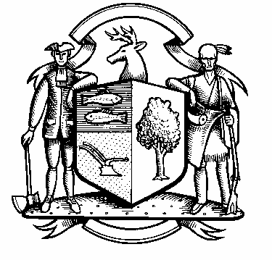

Incorporated 1787

Board of Police Commissioners
Tuesday, July 6, 2021 Agenda
Police Board Meeting
7:00 PM Meeting
Please click the link below to join the Webinar

https://us02web.zoom.us/j/83252560914?pwd=T1VQRnEyeDBnMS8rRmRhcjQya24wZz09
Passcode: 719118
Webinar ID: 832 5256 0914
Passcode: 719118
Dial by phone: 646 558 8656

- Consideration / Approval June 1, 2021 Meeting Minutes

- Chief’s Report
- Current Monthly Reports / OT / Budget (Changes) Updates
- Grant Updates / Donations / Vote
- Facilities Update
- COVID – 19
- Additional Business for Commission Consideration

- Discussion - “Slow Down in Our Town” – Weston Resident Dean Robert

- Discussion – Powers and Duties of Police Commission

- Discussion – Police Accountability Act

- Discussion – Increasing Police Department information to the public

- Discussion – Police Commissioner Badges

- Sub-Committee Reports

Police Department Policy #A0007 – “Complaints that Allege Misconduct by Police Officer”

9. Executive Session / Personnel Updates / Investigation Updates / Security Issues / Juvenile Review
Board Updates / Criminal Activity Updates / Complaints / Traffic Concerns / Union Contract

- Motion to Adjourn

