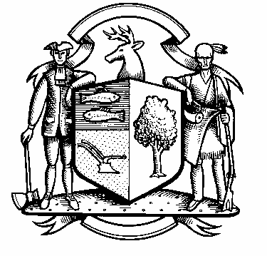

Incorporated 1787

Board of Police Commissioners
Tuesday, March 2, 2021 Agenda
Police Board Meeting
7:00 PM Zoom Meeting
ZOOM MEETING
Join Zoom Meeting
https://us02web.zoom.us/j/82197679004?pwd=WHFTbEVHdldZTzBhRnhUUCtFTD1Vdz09
Meeting ID: 821 9767 9004
PASSCODE: 613049

One tap mobile
+1 929 205 6099, US (New York)
Find your local number:
Find your local number: https://us02web.zoom.us/u/kcnRS4a7Rb
One tap mobile
+1301 715 8592 US (Washington D.C)
+1312 626 6799 US (Chicago)
Dial by your location
+1 301 715 8592 US (Germantown)
+1 346 248 7799 US (Houston)
+1 669 900 6833 US (San Jose)
+1 253 215 8782 US (Tacoma)

- Consideration / Approval February 2, 2021 Meeting Minutes

- 2020-2021 Annual Budget Preparation/Update

- Chief’s Report

- Current Monthly Reports / OT / Budget (Changes) Updates
- Grant Updates / Donations / Vote
- Facilities Update
- COVID – 19
- Additional Business for Commission Consideration

- Sub-Committee Reports

6. Executive Session / Personnel Updates / Investigation Updates / Security Issues / Juvenile Review
Board Updates / Criminal Activity Updates / Traffic Concerns

- Motion to Adjourn

