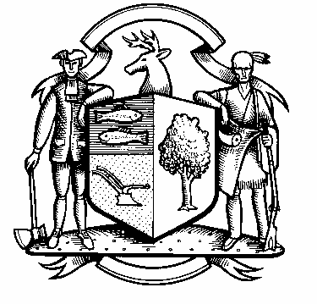

Incorporated 1787

Board of Police Commissioners
Wednesday, November 4, 2020 Agenda
Police Board Meeting
7:00 PM Zoom Meeting
ZOOM MEETING
Join Zoom Meeting
https://us02web.zoom.us/j/86093750609
Meeting ID: 860 9375 0609

One tap mobile
+1 929 205 6099,86093750609# US (New York)
Find your local number:
Find your local number: https://us02web.zoom.us/u/kcPRsLjus
One tap mobile
+13017158592,,81991152420# US (Germantown)
+13126266799,,86093750609# US (Chicago)
Dial by your location
+1 301 715 8592 US (Germantown)
+1 312 626 6799 US (Chicago)
+1 346 248 7799 US (Houston)
+1 669 900 6833 US (San Jose)
+1 929 205 6099 US (New York)
+1 253 215 8782 US (Tacoma)

- Consideration / Approval October 6, 2020 Meeting Minutes

Chief’s Report

- COST October, 8, 2020 Webinar Update – Chairman Gralnick and Commissioner Moch

- Current Monthly Reports / OT / Budget (Changes) Updates
- Policy Review (Update)
- Grant Updates / Donations / Vote
- Facilities Update
- COVID – 19
- Additional Business for Commission Consideration

- Sub-Committee Reports

4. Executive Session / Personnel Updates / Investigation Updates / Security Issues / Juvenile Review
Board Updates / Criminal Activity Updates / Traffic Concerns

- Motion to Adjourn

