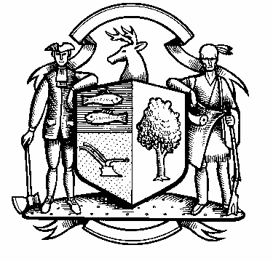

## Incorporated 1787

**Board of Police Commissioners**

**Tuesday, September 1, 2020 Meeting Minutes**

**7:00 PM ZOOM Meeting**

**Board of Police Commissioners Present: Police Board Chairman Beth Gralnick, Police Board Vice Chairman Jess DiPasquale, Police Board Commissioners Susan Moch, Peter Ottomano, Dawn Egan and David Muller**

**Police Board Commissioner Woody Bliss Absent   
  
Others Present: Chief Henion, Captain Brodacki, William Lomas and Ted Kraft**

**Police Board Chairman Gralnick called the Zoom meeting to order at 7:00 PM**

**Consideration / Approval, 18, 2020 Meeting Minutes**

**Police Board Chairman Gralnick made a motion to approve the August 18, 2020 meeting minutes, Police Board Commissioner Muller seconded, motion passed unanimously.**

**Chiefs Report**

**Current Monthly Report OT/Budget (Changes) Updates – Due to Storm Isaias the Police Department had 236 hours of storm patrol for seven days straight. Weston had 112 roads closed and they had to make roads open for emergency vehicles. Sgt. Miceli brought in the National Guard and they paired up with the Highway Department. The Weston Board of Ed has agreed to pay SRO Officers if they work at the school past their scheduled hours.**

**Police Accountability Legislation – Chief Henion discussed the new passed Police Accountability Bill HB6004 in the last legislative special session.**

**Grant Updates / Donations / Vote – No New Grants or Donations.**

**Facilities Update – Renovations are still on going at the Police Department hopefully in six weeks it will be completed.**

**Upcoming Rt. 57 State Bridge Project – The road is now open but they still have to mill and pave the road.**

**Additional Business for Commission Consideration – None at this time.**

**Police Commission/Police Department Initiatives Statement – The Commissioners will post this on the Police Departments Town Website.**

**Sub-Committee Reports**

**Police Board Vice Chairman DiPasquale is revising the Citizen of the Year Award this year. It may be a couple of people in public safety that are helping citizens in the Town of Weston. He is thinking of a vote sometime in November. The Weston Today will have an article.**

**Other Sub-Committee Updates**

**Road signs – Share the road locations: Bill Lomas of the Cycling Committee wanted to thank the Police Commissioners for putting up the Share the Road Signs on some of our roads. He stated he would like to see more signs on additional roads. The Police Commissioners are taking a wait and see approach and said we can revisit this next year.**

**Police Board Chairman Gralnick made a motion to go into Executive Session at 8:24 PM, Police Board Commissioner Moch seconded, the motion passed unanimously.**

**The Police Commissioners came out of Executive Session at 9:06 PM and adjourned.**

**Respectfully submitted**

**Mary Gunshor**

**Board of Police Commissioners Recording Secretary  
Approved 10/6/20**