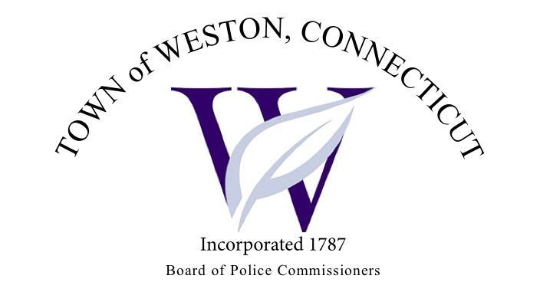

Tuesday, April 2, 2024 Agenda  
Police Board Meeting

7:00 PM Town Hall Commission Room

1. Consideration / Approval March 5, 2024 Meeting Minutes
2. Lyons Plains Road - Traffic
3. Chief’s Report
4. Current Monthly Reports / OT / Budget (Changes) Updates
5. Grant Updates / Donations / Vote
6. Additional Business for Commission Consideration
7. Daigle Law – Accreditation Update
8. Legislative Sub Committee – Consideration of Submitting Testimonial Statement Supporting Passage of SB 431, An Act Concerning Costs for FOIA Compliance By Police Agencies With Dash Cams And Body Cameras
9. Citizen of the Year Award
10. Executive Session / Personnel Updates / Investigation Updates / Security Issues / Juvenile Review Board Updates / Criminal Activity Updates / Complaints / Traffic Concerns
11. Motion to Adjourn