Weston Sustainability Updates
Help Fund the WHS Native Pollinator Courtyard Project
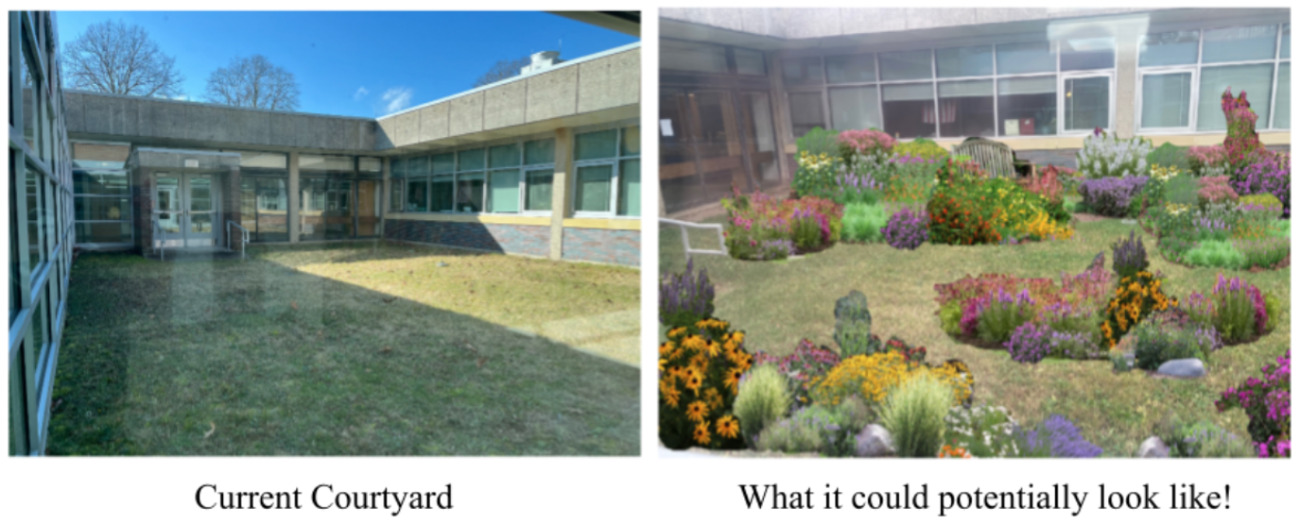
The students of Weston High School’s Sustainable Living class are creating a pollinator garden in one of their courtyards BUT THEY NEED YOUR HELP to fund the project! The students have partnered with Sustainable CT who have offered to provide a matching grant of $4000. But to receive the matching funds, Weston MUST first needs to raise $4000 by April! They are already half way to their goal but now they’re counting on YOU to fill the gap. If you’d like to donate, follow this link: Patronicity.com/westonhighpolinator or send a check made out to Weston High School (add ‘Pollinator Courtyard Project in the memo) to Michael Aitkenhead, Weston High School, 115 School Rd., Weston, CT 06883. You can also bring cash donations with your name (for tracking purposes) to Mr. Aitkenhead in room G7 at the high school. Large donations are welcomed but if many of you even donated just five dollars, it would make a huge difference! So please support our students and help bring this pollinator garden to our school!

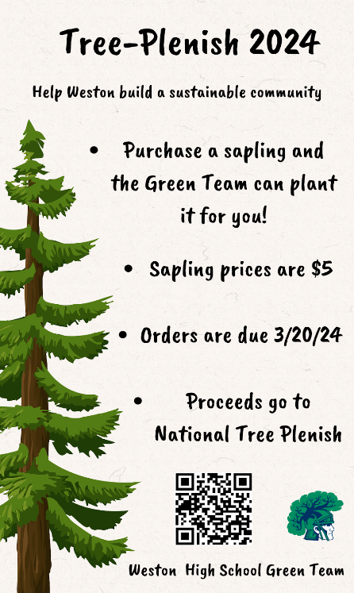
Tree-Plenish 2024
Wondering how to celebrate Earth Day this year?
Why not plant a tree?
For its 3rd straight year, the WHS Green Team is partnering with Tree-Plenish to improve Weston’s sustainability. From February 1 to March 20, WHS Green Team is selling saplings for $5 that can be delivered and planted by high school volunteers in April (final pick-up &/or delivery date TBD). The three available saplings are: Eastern Redbud, Red Maple, and River Birch. After calculating WHS's carbon emissions, The Green Team has set a goal to sell 380 saplings to offset these emissions so do your part to help Weston GO GREEN! Please not that proceeds do not go to support the WHS Green Team but instead go toward the cost of the sapling and to support the National Tree-Plenish organization.

To make a purchase, click here
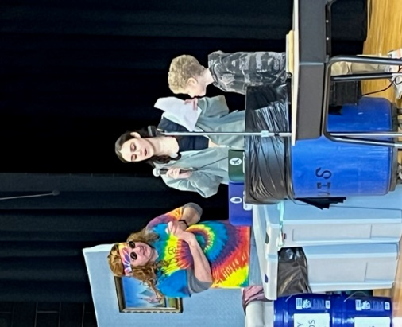
Composting Kick-Off at WIS
a HUGE success!
With the help of WHS students and ‘Michael Recycle,’ Weston Intermediate School has joined WHS and WMS in launching their cafeteria composting program. The WIS students were a fantastic audience for the roll-out presentation and there’s no doubt they will keep contaminants out of the food waste bins to make this program a success!
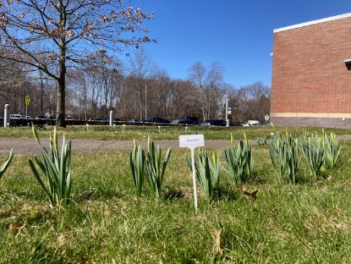
The Daffodils Are Back!
Spring must be here because this year’s section of the Senior Daffodil Legacy Trail is already starting to bloom! If you purchased daffodils on behalf of your graduating senior, be sure to stop by in the coming weeks to see the labeled section of trail planted in their honor.

Trout in the Classroom – Alive and Well!
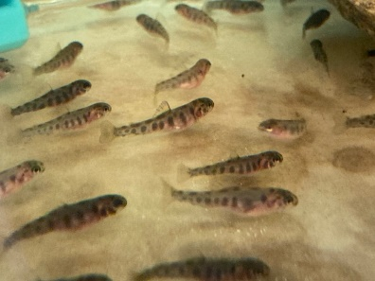
This year’s batch of trout are doing phenomenally well. Each year, students in the Standard and AP Environmental Science courses receive some 400 trout eggs, which are hatched and cared for in the classroom. Students carefully test and monitor the water quality in the tanks as part of a larger national program sponsored by Trout Unlimited to raise awareness about protecting our fragile watershed ecosystems. In May, the young trout will be released by students into a local river system to maintain our populations of healthy trout.

Sustainability Student Project Updates:
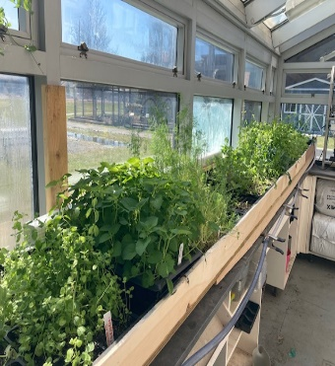
WHS Greenhouse is Growing Green again!
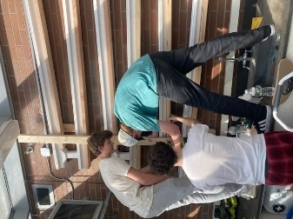
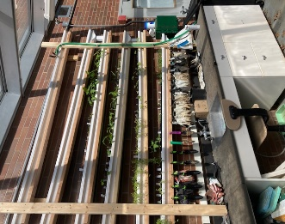
With funds from the recently awarded CT Grown for CT Kids grant, one of the latest projects in the Sustainability Course has been restoring the underutilized greenhouse. Students designed and built a vertical automatic plant watering system and an automatic watering table… the first batch of plants for the vegetable garden are already well under way!

