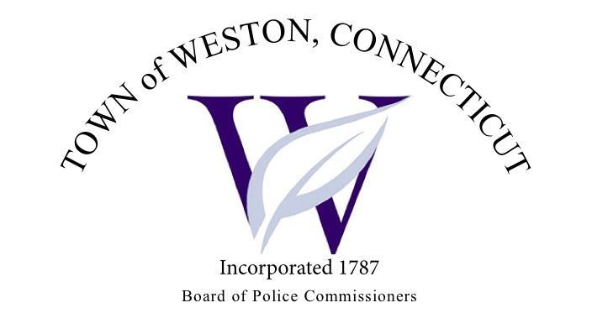

Tuesday, February 6, 2024 Meeting Minutes  
7:00 PM Town Hall Meeting Room

Board of Police Commissioners Panelists: Police Board Chairman Beth Gralnick,  
Police Board Vice Chairman Peter Ottomano, Woody Bliss, Dawn Egan, David Muller, John Dembishack and Frank Ferrara

Others Present: Chief Henion, Captain Brodacki   
  
Police Board Chairman Gralnick called the meeting to order at 7:00 PM.

Police Board Chairman Gralnick made a request to approve the meeting minutes dated January 2, 2023, Police Board Commissioner Muller moved and Police Board Commissioner Egan seconded, and unanimously approved.

Chief Henion reported to the Police Board of Commissioners about overtime, criminal arrests, investigations and two motor vehicle thefts which has brought up overtime. The Police Department has two officers out. Chief Henion also discussed the budget with the Police Board of Commissioners. Officers are completing mandatory Training.

The Police Department has not received any donations for February.

Captain Brodacki has been working with Daigle Law regarding the accreditation updates which is ongoing.

Citizen of the Year Award – Police Board Commissioner Egan will be organizing the

Citizen of the Year Award along with the Police Board of Commissioners.

Legislature Sub Committee Report – Police Board Vice-Chairman Ottomano, Police Board Commissioner Egan and Police Board Commissioner Muller shared a letter they wrote to our State Representatives stating their concerns. The Police Board of Commissioners and the Chief and Captain all worked to update and make changes to the letter.

Police Board Commissioner Muller made a request to go into Executive Session at 7:53 PM, Police Board Commissioner Egan seconded and unanimously approved.  
  
The Police Board of Commissioners came out of Executive Session at 8:35 PM and adjourned.   
  
Respectfully submitted  
Mary Gunshor  
Board of Police Commissioners Recording Secretary  
Approved March 5, 2024