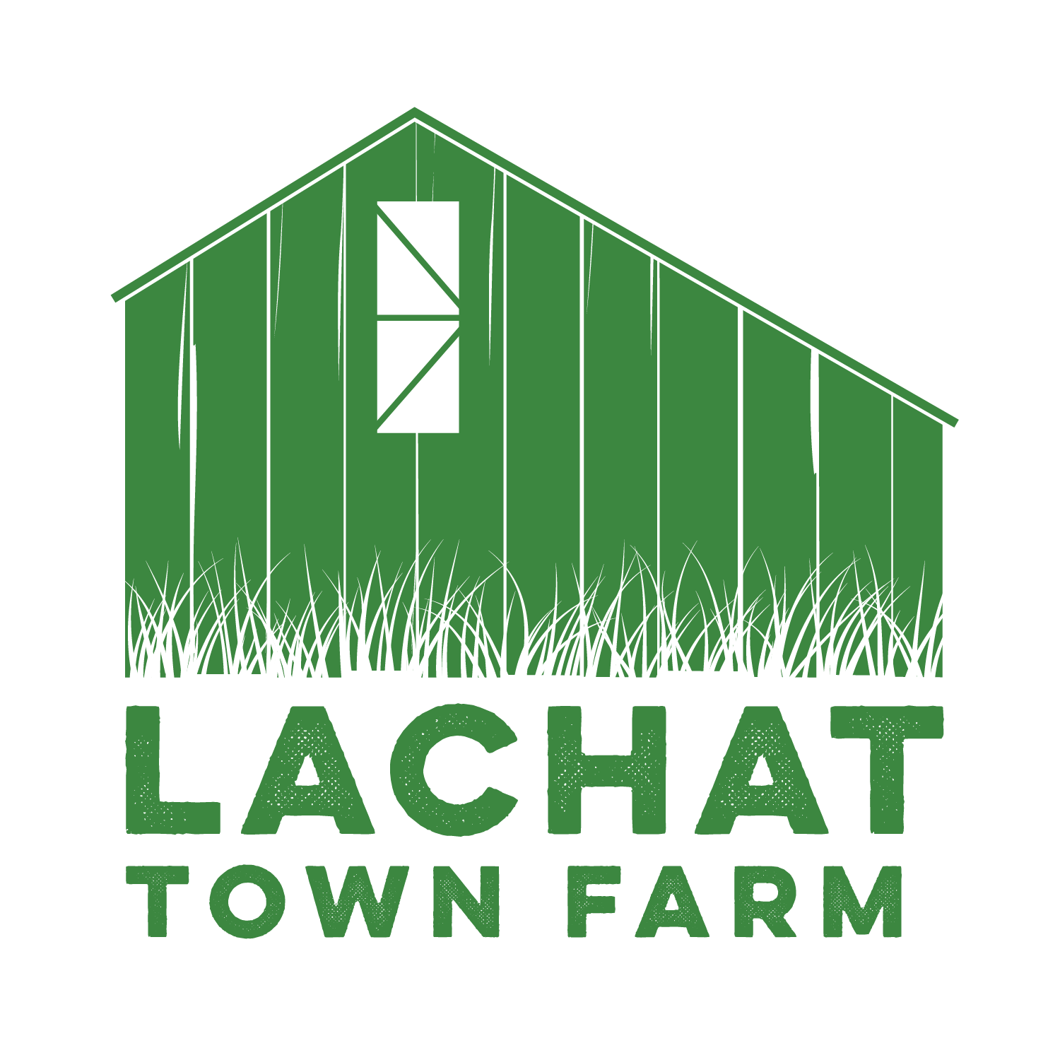

Lachat Town Farm Commission Meeting Agenda

Meeting Held at Lachat

**Date**: 03/05/24

**Time**: 7:30pm

1. Call to Order

2. Approval of Minutes from 02/06/24

3. Around the Farm Spotlight – Pedro Reis de Oliveira

4. Anita – Upcoming Events

5.Chairman’s Report -

1. Commission member replacement

6. Committee Reports -

a) Buildings Maintenance - Carol Baldwin

b) Grounds Maintenance- Ellen McCormick

1. Barnyard - Kat McConnaughey
2. Bee Yard/ Bee Friends - Erica Reiner
3. Farm Equipment Maintenance – Stirling Collins
4. Wishlist – Erica Reiner

7. Audience of Citizens – 3 minutes or less per person

8. Motion to adjourn