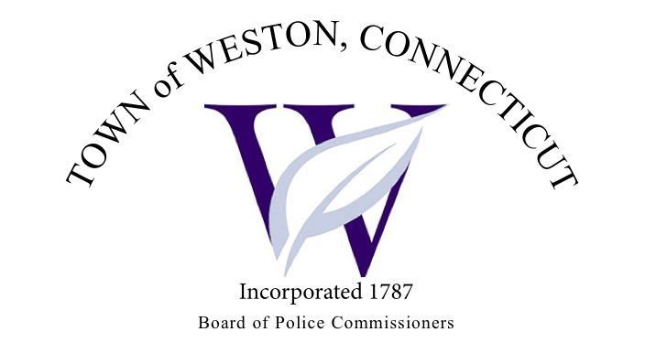

Tuesday, February 6, 2024 Agenda  
Police Board Meeting

7:00 PM Commission Room

1. Consideration / Approval January 2, 2024 Meeting Minutes
2. Chief’s Report
3. Current Monthly Reports / OT / Budget (Changes) Updates
4. Grant Updates / Donations / Vote
5. Additional Business for Commission Consideration
6. Daigle Law – Accreditation Update
7. Citizen of the Year Award
8. Legislature Sub Committee Report
9. Executive Session / Personnel Updates / Investigation Updates / Security Issues / Juvenile Review Board Updates / Criminal Activity Updates / Complaints / Traffic Concerns
10. Motion to Adjourn