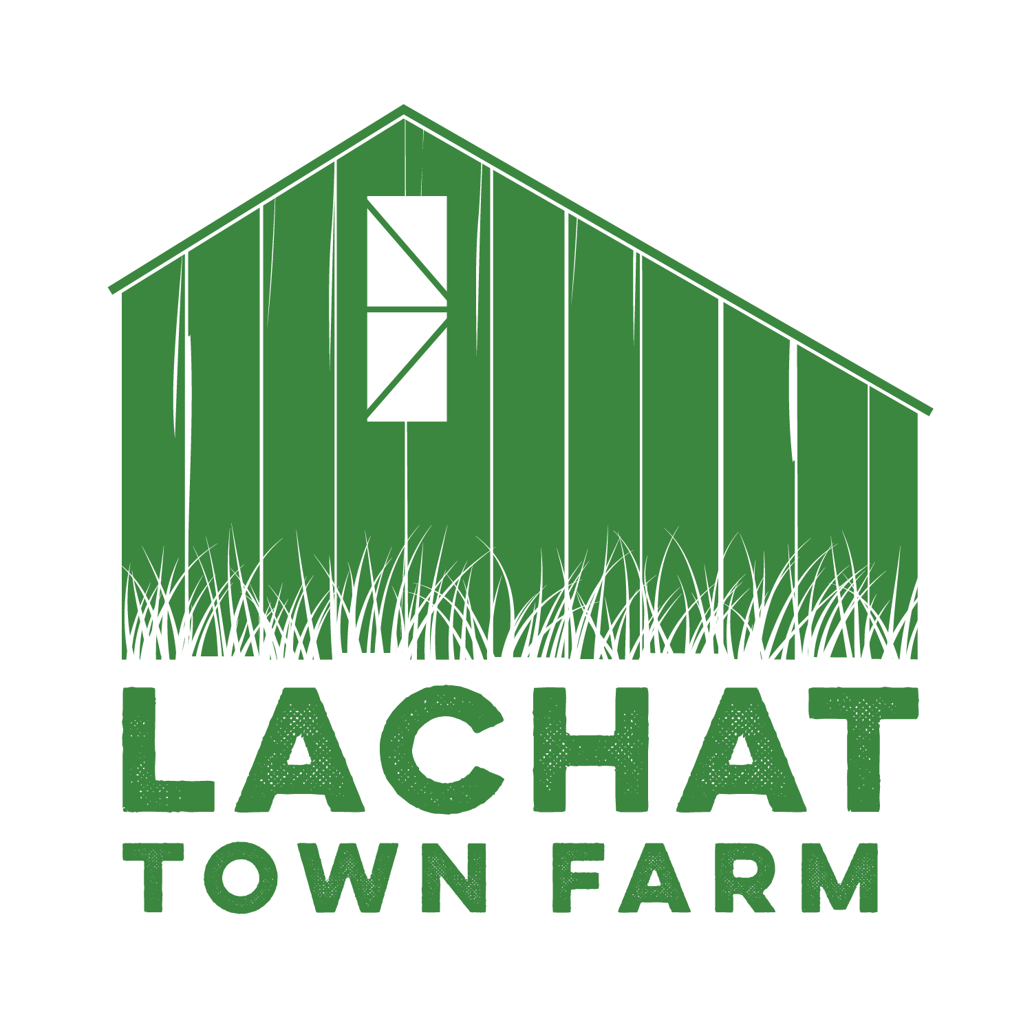

Lachat Town Farm Commission Meeting Agenda  
Held In-Person Lachat Town Farm  
**Date**: 1/09/24  
**Time**: 7:30pm

1. Call to Order  
2. Approval of Minutes from 12/05/23  
3. Vote on Commission Chair

4. Introduction of Aiden Baker - the first Lachat Town Farm Junior Advisory Committee Member   
5. Ellen - report on the Fire Pond flooding

6. Nicole - report on the new Wishlist  
7. Audience of Citizens: 3 Minutes or less per person.

8. Motion to adjourn