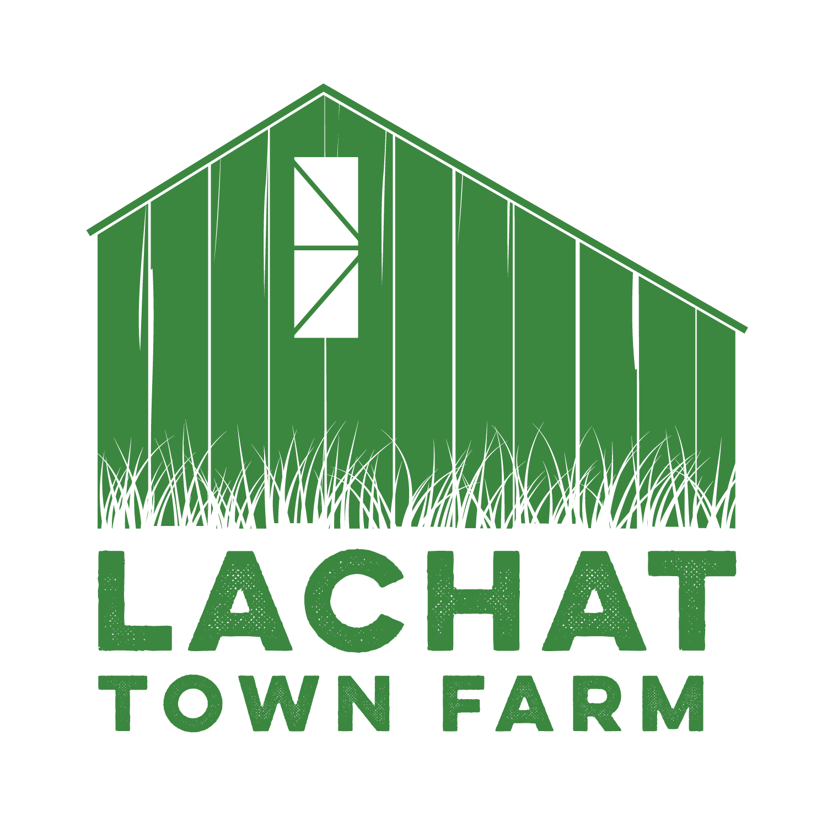

Lachat Town Farm Commission Meeting Agenda  
Held In-Person Lachat Town Farm  
**Date**: 12/05/23  
**Time**: 7:30pm

1. Call to Order  
2. Approval of Minutes from 11/07/23  
3. Carriage Barn- cleanup, particularly how to dispose of the concrete bags

4. Kiosk- usage and verbiage considerations for Regulation page. New Map consideration.  
5. Announcements  
6. Audience of Citizens: 3 Minutes or less per person.

7. Motion to adjourn