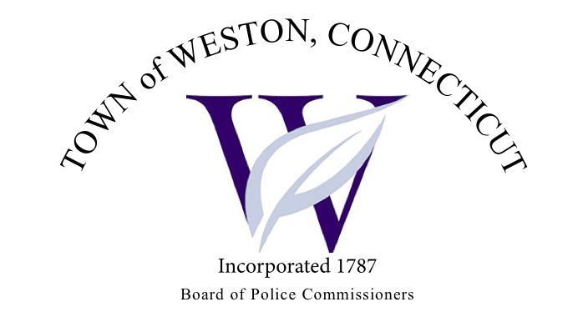

Tuesday, December 5, 2023 Agenda  
Police Board Meeting

7:00 PM Commission Room

1. Consideration / Approval November 14, 2023 Meeting Minutes
2. Chief’s Report
3. Current Monthly Reports / OT / Budget (Changes) Updates
4. Grant Updates / Donations / Vote
5. Additional Business for Commission Consideration
6. Daigle Law – Accreditation Update
7. Rt. 53 (Norfield Road) – Safety Issue at Intersection at Ridge Road
8. Signage at Unpaved Section of Newtown Tpk
9. Street Art - Continued Discussion
10. Executive Session / Personnel Updates / Investigation Updates / Security Issues / Juvenile Review Board Updates / Criminal Activity Updates / Complaints / Traffic Concerns
11. Motion to Adjourn