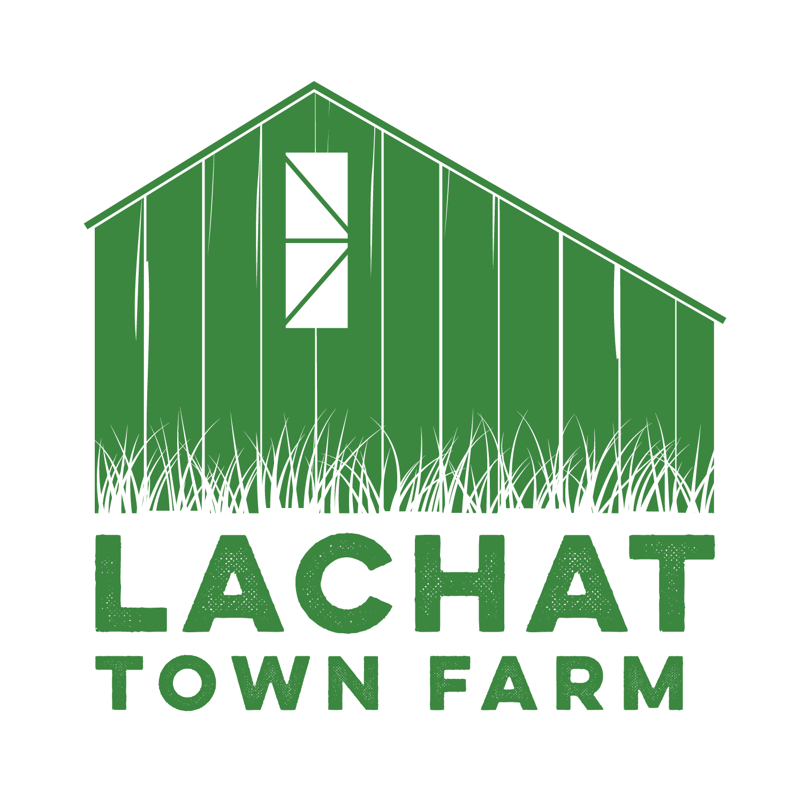

Lachat Town Farm Commission Meeting Agenda  
Meeting Held via Zoom <https://zoom.us/j/92751803423?pwd=Z2hhaEVvQlgrOC96S2U1dEpGbW91Zz09> **Phone Number Dial-In:**1 305 224 1968  
**Meeting ID:**927 5180 3423 **Passcode**: 897895  
**Date**: 11/07/23  
**Time**: 7:30pm

1. Call to Order  
2. Approval of Minutes from 09/05/23  
3. Kiosk- usage and verbiage considerations for Regulation page.  
4. Bee Initiative with BYBA  
5. Wetlands discussion  
6. Haywagon Safety

7. Follow up on Grants   
8. Audience of Citizens: 3 Minutes or less per person..

9. Motion to adjourn