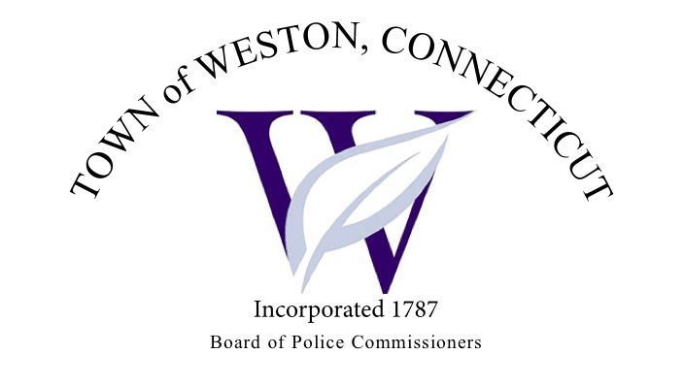

Tuesday, September 5, 2023 Meeting Minutes  
7:00 PM Town Hall Meeting Commission Room

Board of Police Commissioners Panelists: Police Board Chairman Beth Gralnick, Police Board Vice-Chairman Jess DiPasquale

Board of Police Commissioners: David Muller, Peter Ottomano, John Dembishack, Woody Bliss and Dawn Egan   
  
Others Present: Chief Henion, Captain Brodacki and Residents  
  
Police Board Chairman called the meeting to order at 7:00 PM.   
  
Police Board Chairman Gralnick made a request to approve the meeting minutes dated August 1, 2023, Police Board Commissioner Muller moved and Police Board Commissioner Bliss seconded, and unanimously approved.

Chief Henion reported to the Police Board Commissioners that overtime was up $6,862.00 due to training and an officer is out on workers compensation. The Police Department has not received any donations for the month of August.   
  
Additional Business for Commission Consideration – Police Board Commissioner Muller suggested that the Police Commission and Police Department have a gathering with residents regarding the motor vehicle thefts. Chief Henion plans on doing coffee with a Police Officer in the fall.

Daigle Law – Accreditation Update – Captain Brodacki continues to work with the Daigle Law Group in updating the policies.

Discussion – Fanton Hill Road – Police Board Vice Chairman DiPasquale made a motion for a new stop sign on Fanton Hill Road at Old Easton Turnpike making it a three way stop, Police Board Commissioner Bliss seconded, and unanimously approved.

The Police Department will contact Eversource about the sub-contractors trucks speeding on Fanton Hill Road that are hauling rip rap. Once the Police Department hits a thirty day mark on Fanton Hill they will pull data from the speed trailer.

Discussion – Emergency Accessway – Wood Hill Road and School Road – Police Board Commissioner Egan made a motion to put permanent “No Parking, No Standing” signs at the end of Wood Hill Road, at access point and also on the School Road side, Police Board Commissioner Dembishack seconded, and unanimously approved.

Police Board Commissioner Ottomano made a motion to go into Executive Session at 8:10 PM, Police Board Vice-Chairman DiPasquale seconded and unanimously approved.  
  
The Police Board Commissioners came out of Executive Session at 8:50 PM and adjourned.   
  
Respectfully submitted  
Mary Gunshor  
Board of Police Commissioners Recording Secretary  
Approved 10/3/2023