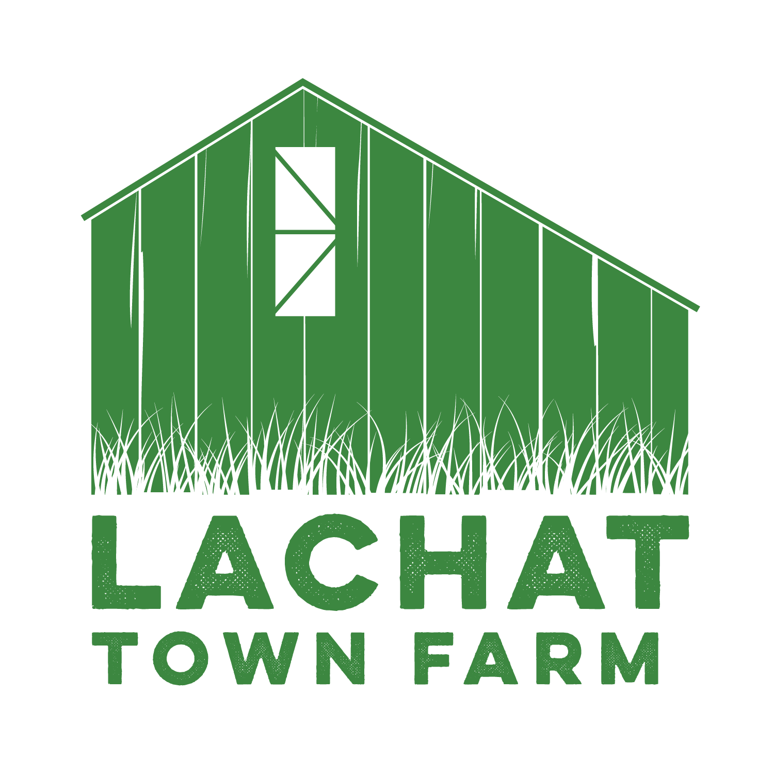

Lachat Town Farm Commission Meeting Agenda

Meeting Held via Zoom

https://zoom.us/j/92751803423?pwd=Z2hhaEVvQlgrOC96S2U1dEpGbW91Zz09

**Phone Number Dial-In:** 1 305 224 1968

**Meeting ID:** 927 5180 3423 **Passcode**: 897895

**Date**: 8/1/23

**Time**: 7:30pm

1. Call to Order
2. Approval of Minutes from 7/5/23
3. Opening Day plan and call for volunteers
4. ARPA funds update
5. Offutt Education Center Update
6. Audience of Citizens: 3 Minutes or less per person
7. Motion to Adjourn