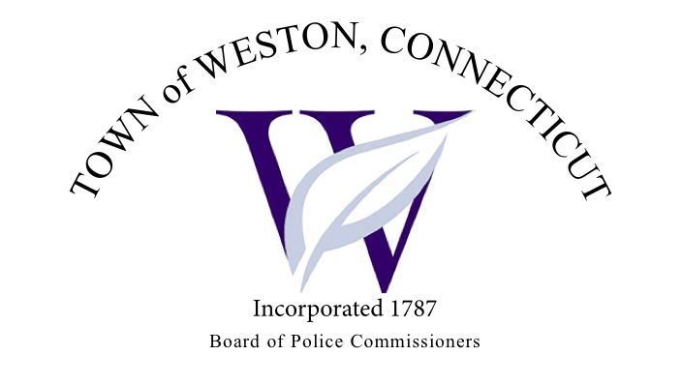

Tuesday, July 11, 2023 Agenda  
Police Board Meeting

7:00 PM Commission Room

1. Consideration / Approval June 6, 2023 Meeting Minutes
2. Chief’s Report
3. Current Monthly Reports / OT / Budget (Changes) Updates
4. Grant Updates / Donations / Vote
5. Additional Business for Commission Consideration
6. Daigle Law – Accreditation Update
7. Discussion/Decision – Georgetown Village Restoration Sign on Rt. 57 and Old Georgetown Road
8. Server Upgrade – Captain Brodacki
9. Discussion – Future Unfunded Mandates – Captain Brodacki
10. Homeland Security School Safety Assessments – Captain Brodacki
11. Executive Session / Personnel Updates / Investigation Updates / Security Issues / Juvenile Review Board Updates / Criminal Activity Updates / Complaints / Traffic Concerns
12. Motion to Adjourn

﻿