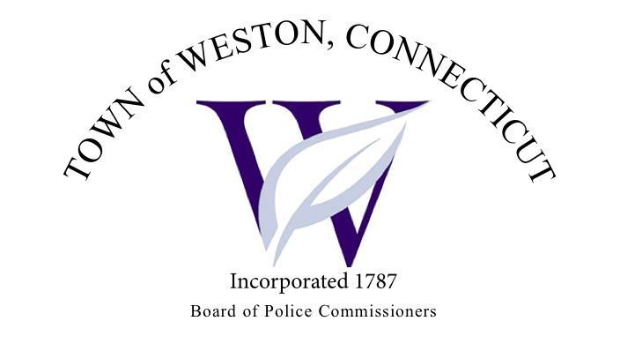

Tuesday, June 6, 2023 Agenda  
Police Board Meeting

7:00 PM Commission Room

1. Consideration / Approval May 2, 2023 Meeting Minutes
2. Chief’s Report
3. Current Monthly Reports / OT / Budget (Changes) Updates
4. Grant Updates / Donations / Vote
5. Additional Business for Commission Consideration
6. Daigle Law – Accreditation Update
7. Request for a Stop Sign/Speed Hump at Greenfield Dr and Walker Lane – Andres Oranges
8. Community Education Effort for Safe Gun Storage – Commissioner Egan
9. CT Challenge
10. Executive Session / Personnel Updates / Investigation Updates / Security Issues / Juvenile Review Board Updates / Criminal Activity Updates / Complaints / Traffic Concerns
11. Motion to Adjourn

﻿